16.63: a) The wall serves as the listener, want 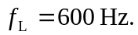
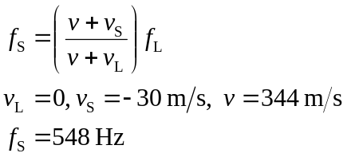
b) Now the wall serves as a stationary source with 